|  |  |  |
| --- | --- | --- |
| **شعار جامعة بنها الجديد**f |  | **logo.jpg** |
| Benha University |  | Faculty of Computers & Informatics |

**Genius Education**

Object Oriented Programming

**Second Year**

*Project Team*

1. Ahmed Mohy Younis

Section 2

Benha, May 2018

**Abstract**

Genius Education is a program that makes educational system easier and contains accounts for students which will be used to download courses matrial and enable staff uploading their matrial. İt fully manages the whole process and let you to control it..

**Introduction**

Genius Education is totally ready but while building it.. There were many problems such that stressness because I am working alone but i overed it by working hard, another problem to find a way to upload and download matrial, we used advanced features so we needed to search more and working with new things that we didn't know before, and also there is lisly who will help you inside the program.. she is speaking voice and you have the ability to make her silent. At last there were small problems like opening file, updating accounts...etc.

**Program Interface**

When you open the program you will meet Lisly and a login form which is the parent of every thing in the program, from it you can set up The settings of the program or login for uploaing or downloading the matrial.

In Any form you are in the program just press the exit button to close the program.

**Program Execution**

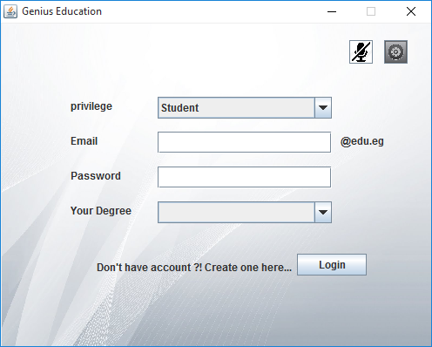On the beginning of execution the program this window will appear

İn which you can start up the usage of the program

There is a voice button which shut up Lisly next to the settings button that if you pressed a Checker Window Will Appear to request a password to pass

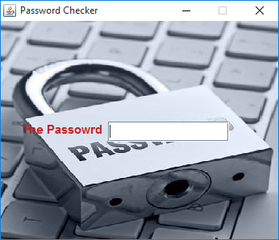

And that is it, just when you enter the password correctly and press the " Enter " key the setting window will appear

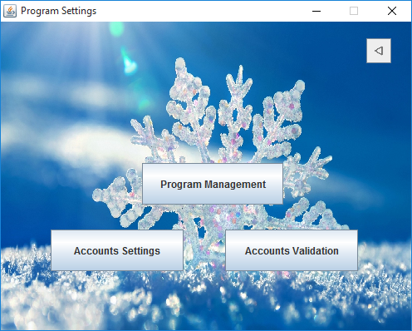

This window has 4 buttons as it shows

Firstly, if you press the " Program Management " Button a new Form will appear to help you to manage the program courses and staff jops..

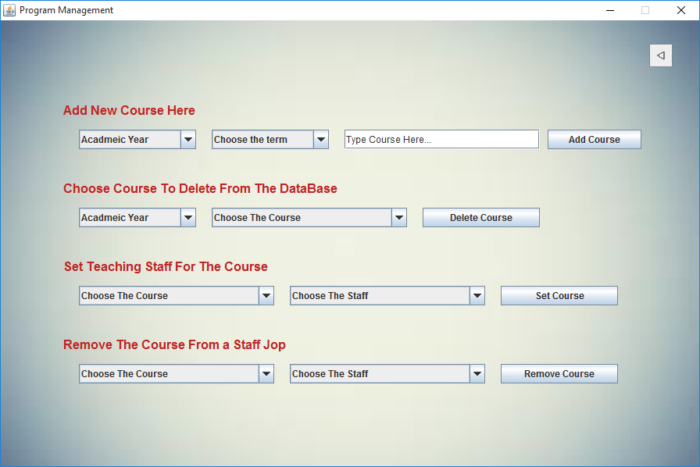

As you can see you can add new course or delete old course either setting the staff which work on the course   
or remvoe old or retired ones. But only if you are the manager. Definitly, Lisly will help you there.

Secondly, if you press the " Accounts Validation " button a new form will appear to help you activate or deactivate the accounts on the program and you can see it below

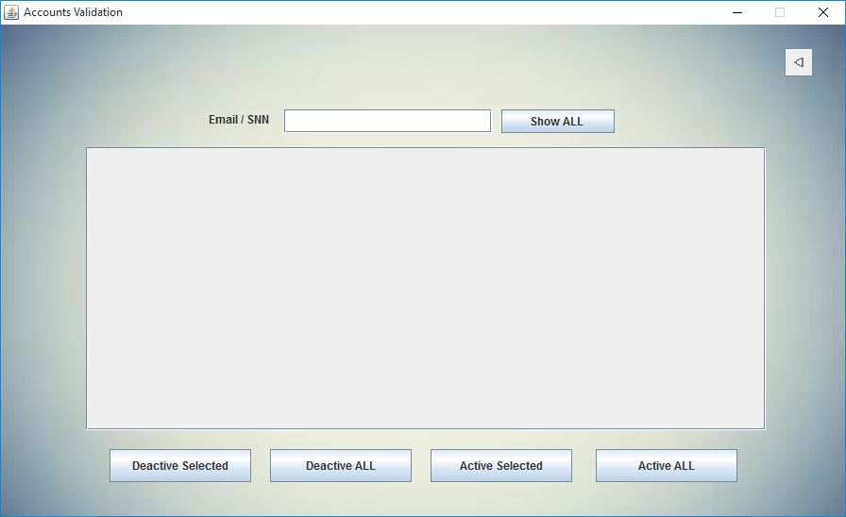

Thirdly, if you press the " Accounts Setting " Button a new window will appear to help you to creat accounts for Staff and recover any accounts if needed. As you can see below.

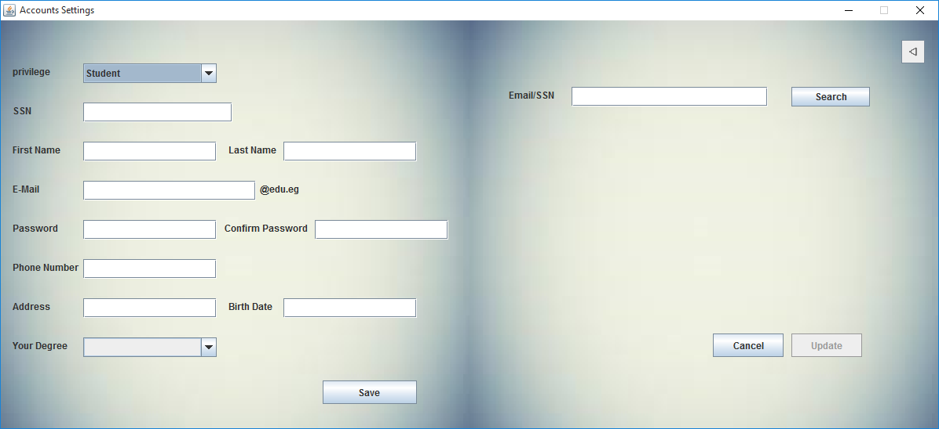

Lets back to the login window and see what are there else?

In the Login window you can login as one of the staff to upload the matrial with the helping of this window

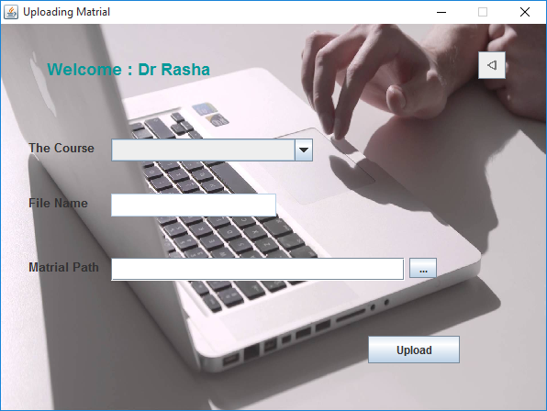

You just choose one of your courses pick up the folder and click upload button

And also you can login as a student to download the matrial  
as shown there

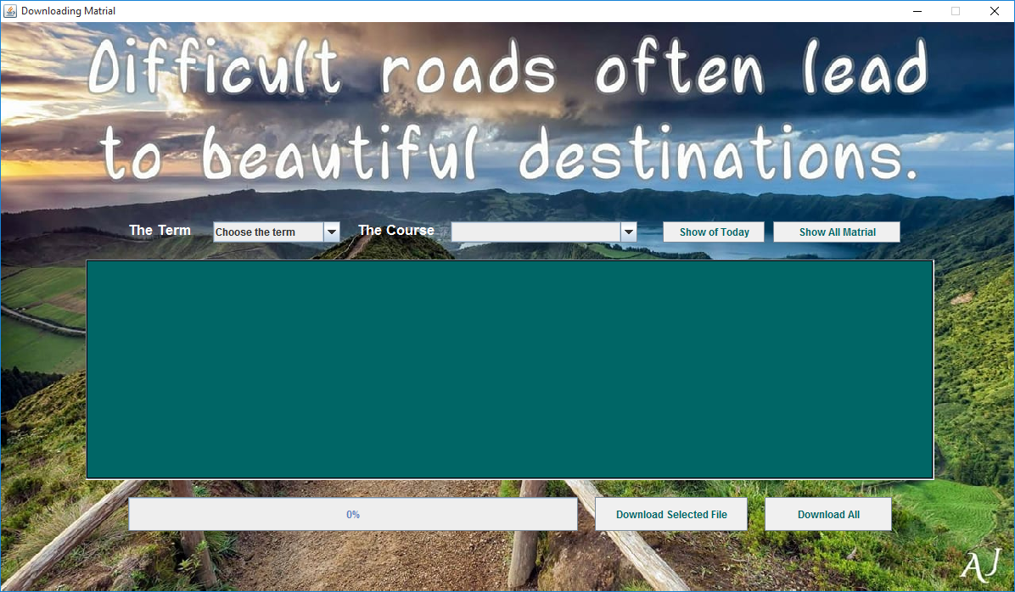

You choose the course click the show buttons to watch the matrials and download it

But first you need to have an account so you can creat on by clicking the create link and then set up your information and save it..

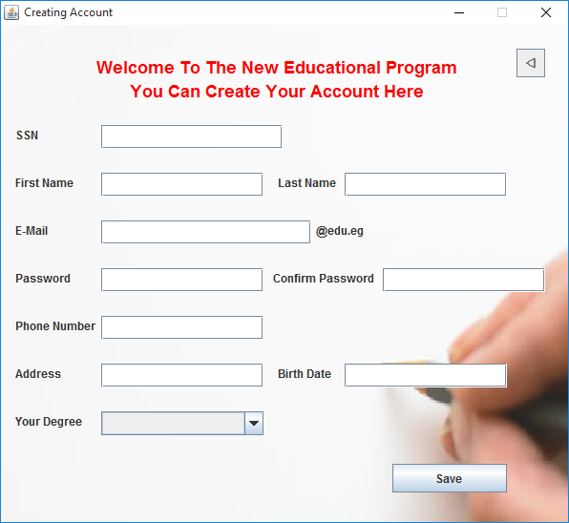

Well, at the last you can notice that each window has a Back Button to return to the previous window

**Examples**

For examples in the program, you click a button to choose any file to upload it.. you search account to activate by entering the Social Security Number , or the email, you can recover missing accounts you can search for new matrial to download it ...

**Conclusion**

Our first Target was to faciltate the educational system and creating a cooperated enviroment to help in creating good future of the students.  
And finish the bad environment of The Facebook, by ending using the Facebook groups and starting using Genius Education to connect the staff with the students.

With Genius Education it will be easy to educate and learning and we hope to supply it in universities.